External scientific Report

User manual for the TSE Infectivity Model (TSEi)[1]

Amie Adkin, Robin Simons and Mark Arnold

Animal Health and Veterinary Laboratories Agency (AHVLA), Weybridge, UK

Abstract

A user friendly interface has been developed within project CFT/EFSA/BIOHAZ/2012/02 to accompany the TSE Infectivity Model in animal tissues (TSEi). This stochastic quantitative risk assessment has been developed, supported by a user-friendly interface, to evaluate the different levels of infectivity in animal tissues infected with a Transmissible Spongiform Encephalopathy (TSE). The model uses tissue specific data to estimate the amount of infectivity by age at slaughter and uses European Member State (MS) specific data to scale up to an annual estimate. This manual describes how to install the model package, open the model, change model settings and parameters using the user interface, selection of risk management options, and investigation of results. Two template risk assessments have been provided: BSE in cattle including ileum, duodenum, jejunum, caecum, colon and mesenteric tissues, and Scrapie in sheep including brain, muscle and ileal Peyer’s Patches. The BSE in bovine intestines and mesenteries model has been validated, whereas the Scrapie model is currently provided for demonstration purposes.

Key words

*Bovine Spongiform Encephalopathies, BSE, risk assessment, model, bovine intestines, mesentery tissues*

Disclaimer

The present document has been produced and adopted by the bodies identified above as author(s). This task has been carried out exclusively by the author(s) in the context of a contract between the European Food Safety Authority and the author(s), awarded following a tender procedure. The present document is published complying with the transparency principle to which the Authority is subject. It may not be considered as an output adopted by the Authority. The European Food Safety Authority reserves its rights, view and position as regards the issues addressed and the conclusions reached in the present document, without prejudice to the rights of the authors.

Table of contents

Background as provided by EFSA 3

Terms of reference as provided by EFSA 4

Materials and Methods 7

Results 7

1. Installation 7

2. TSE QRA Builder 7

2.1 First time use: load @Risk Reference libraries then save to Microsoft template folder 7

2.2 Summary of QRA Builder template 8

2.3 User interface – getting started 9

2.3.1. User interface: Simulation Tab 9

2.3.2. User interface: SRM Tab 10

2.3.3. User interface: Processing Tab 12

2.3.4. User interface: Update Model Settings Tab 13

2.3.4.1. Update Simulation Settings: BSE QRA Builder 13

2.3.4.2. Update Simulation Settings: Scrapie QRA Builder 14

2.3.5. User interface: Save Tab 15

2.4 Model worksheet “Model” 15

2.5 Surveillance worksheet “Surv” 16

2.6 Abattoir worksheet “Abattoir” 17

2.7 SRM worksheet “SRM” 17

2.8 Processing worksheet “Processing” 18

2.9 Infectivity worksheet “Infectivity” 18

2.10 Results worksheet “Results” 18

3. Running the model 19

3.1 Ensuring convergence with new bespoke models 19

3.2 Macros 20

4. Investigating results 21

4.1. Sensitivity analysis 22

5. Trouble-shooting 23

References 24

Appendix: BSE QRA Builder – manual incorporation of surveillance data into Surveillance worksheet 25

Worksheet Surv: pattern of infectivity by age at slaughter 25

Worksheet Surv: baseline simulation (2012) 25

Worksheet Surv: historic simulation (2007 and 2011) 26

Worksheet Surv: re-emergence simulation 26

Glossary [and/or] abbreviations 28

Background as provided by EFSA

Specified Risk Material (SRM) – such as brain, spinal cord and intestine of animals of certain species/ages – are defined in Regulation (EC) No 999/2001[2] and are considered as the animal tissues potentially containing the highest level of Transmissible Spongiform Encephalopathies (TSE) infectivity and that have to be removed from the food and feed chain. The removal of SRM is the most important public health protection measure against TSEs in the European Union (EU). So far, the EFSA Scientific Panel on Biological Hazards has issued eight Scientific Opinions that were used by the Risk Manager to define and update the list of SRM. Some examples are reported here below:

* Scientific Opinion on a review of the Bovine Spongiform Encephalopathy (BSE)-related risk in bovine intestines[3].
* Scientific Opinion on BSE/TSE infectivity in small ruminant tissues[4].
* Scientific Opinion on consumption of beef tongue: Human BSE risk associated with exposure to lymphoid tissue in bovine tongue in consideration of new research findings[5].
* Scientific Opinion on the assessment of the age limit in cattle for the removal of certain Specified Risk Materials (SRM)[6].

Taking into consideration the current favourable evolution of the epidemic of BSE in the EU and on the basis of the current scientific knowledge, the strategic paper “TSE Roadmap 2”[7] recently issued by the European Commission foresees the possibility to modify the list/age limit for the removal of SRM without compromising the current level of consumer protection. In the course of recent years the implementation of active TSE surveillance in the EU has allowed the identification of different types of TSEs in ruminants such as Classical BSE, H-type Atypical BSE and L-type Atypical BSE in bovines and Classical scrapie and Atypical scrapie in small ruminants. A recent publication raises the possibility of a new type of TSE in bovine animals being identified[8]. In this context, the European Commission has submitted to EFSA a mandate for a quantitative risk assessment of the BSE risk i) in bovine intestines, both when unprocessed and processed (casings), and ii) in bovine mesentery. It is likely that the Commission may send to EFSA additional mandates on other SRM-related subjects in the future.

Terms of reference as provided by EFSA

The terms of reference for this work is to provide EFSA with a flexible and transparent model supported by a “user-friendly” interface that would be employed to assess the TSE infectivity level in animal tissues with the aim to provide quantitative answers informing the Risk Manager in the definition/update of the SRM list. This model will support the EFSA BIOHAZ Panel and, where appropriate, the associated *ad hoc* Working Groups in the development of future Opinions related to the review of the SRM list in the EU. A training session to future users of the model must also be provided. The specific objectives of the contract resulting from the present procurement procedure are as follows:

1. To develop a flexible and transparent model to assess and compare:

* the infectivity level of different TSE agents in animal tissues/organs;
* the impact of possible amendments to the list/age for removal of SRM on the residual TSE infectivity level both at single animal and at animal population level;
* the impact of certain processing technologies on the residual TSE infectivity level of some animal tissues/organs or products.

The model shall employ a “user-friendly” interface that would allow for the input of the various data and parameters needed.

1. To provide results on the application of the model to an initial set of animal tissues/organs and processing technologies. Namely, bovine intestines and mesentery (including mesenteric fat) and their related risk management measures (e.g. their inclusion in or exclusion from the SRM list) and the impact of processing technologies applied to these tissues/organs (e.g. processing of bovine intestines into casings).
2. To provide EFSA with two draft reports and a final report.
3. To develop a user manual.
4. To deliver a training session for EFSA staff and other potential users.
5. To work closely with EFSA and with relevant experts and to participate in up to four physical meetings and four web-conferences with EFSA.
6. To provide assistance during the period after delivery of the final model until the end of the contract where necessary.

This contract was awarded by EFSA to:

Contractor: Animal Health and Veterinary Laboratories Agency, UK

Contract title: “Model on the TSE infectivity level in animal tissues”

Contract number: CFT/EFSA/BIOHAZ/2012/02

Introduction and Objectives

This report describes the user manual for the TSE infectivity Model (TSEi). The objective of the overarching project is to develop a flexible and transparent quantitative risk assessment (QRA) supported by a user-friendly interface to assess quantitatively the TSE infectivity level in animal tissues. The model developed permits:

* Comparison of the level of infectivity of different TSE agents in animal tissues/organs
* Estimation of the impacts of possible amendments to the list/age for the removal of SRM on residual TSE infectivity levels both at single animal and member state level over one year
* Estimation of the impact of certain processing technologies on residual TSE infectivity in some animal tissues or products

The TSEi QRA has been developed initially to focus on bovine intestines and mesentery and their related processing technologies, the parameterisation and results of which are contained in this report. An additional risk assessment is supplied in this report concerning classical scrapie in sheep, supplied for demonstration purposes. The risk assessment and user interface has been written as a transparent and flexible software package in Excel using VB code and the add on @Risk (Version 6.2.1 Palisade ™).

The overarching modelling framework has been developed to enable users to investigate various SRM regimes and processing techniques in Member States (MSs). The model requires estimates, where available, of parameter uncertainty and the natural variability of input parameters through the use of distributions and stochastically modelling individual infected cattle. The overarching framework is given in Figure 1. The model is divided into five data worksheets: (1) surveillance, (2) abattoir, (3) SRM, (4) processing, and (5) infectivity, which all feed into a central “model” worksheet; the first five worksheets contain the data to characterise a randomly selected infected animal whilst the model worksheet uses this information and scales up to an annual contribution of infectivity into the food chain for a country or country grouping, for example, the EU27.

A user-interface has been developed which permits the user to select the types of required outputs from the risk assessment and other options such as member state data to be used, tissue types and to define specific scenarios to be investigated. The roles and outputs of each of the worksheets are described in more detail in the following sections.

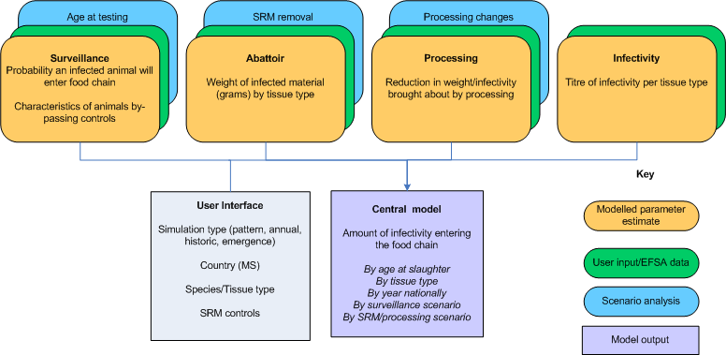

Figure 1: Overarching framework TSE infectivity model (TSEi)

Two TSE QRA Builders are provided;

1. BSE in bovine intestines and mesentery tissues (including ileum, duodenum, jejunum, caecum, colon and the mesenteric lymph nodes, mesenteric nerves and the celiac and mesenteric ganglion complex).
2. Scrapie QRA builder encompassing the tissue types muscle, brain, and ileal Peyer’s Patches.

The two templates provided make use of the same user friendly interface; however, there are significant differences between the templates based on currently available livestock demographic data, disease pathogenesis, magnitude of the estimated numbers infected, and livestock genotype resistance. For BSE in cattle, a model has been developed which estimates the number of BSE infected cattle under certain scenarios (Adkin et al., 2012). The outputs from this model, named C-TSEMM enables a number of scenarios to be included in the BSE QRA risk assessment that are not available for other TSE-livestock QRAs. Additionally, for atypical scrapie and atypical BSE there has been far less experimental data generated to support the modelling of infectivity developing over time when compared to classical BSE in cattle and classical scrapie in sheep. Particularly for sheep and to a lesser extent for goat TSEs, genetics strongly influence pathogenesis and thus the probability of infection, the progress of infectivity through peripheral and CNS tissues and final tissue infectivity titres. Therefore, the level of complexity that can be developed within risk assessments for different animal species and TSEs is dependent on the level of input data that is available.

This report describes installation of the risk assessment package, opening the model templates, changing the model settings and parameters using the user interface, selection of risk management options, and investigating results. Two template risk assessments have been provided: BSE in cattle including ileum, duodenum, jejunum, caecum, colon and mesenteric tissues, and Scrapie in sheep including brain, muscle and ileal Peyer’s Patches. Further descriptions of the parameterisation of the BSE in bovine intestines and mesenteries model is available in the main report[9].

Materials and Methods

The risk assessment and user interface has been written as a transparent and flexible software package in Excel using VB code and the add on @Risk (Version 6.2.1 Palisade ™).

Results

Installation

In order to view the model Excel 2007 or 2010 is required on the machine. In order to create new simulations using the model @Risk version 6.1 (Palisade ™) has been used. To install the package, move or save all files to the C drive of the computer. In order for the correct functioning of the hard coding the direct location is C:\TSEi. There are three folders within the package, as shown in Figure 2:

* TSE QRA Builder - contains the Excel templates to build bespoke risk assessments
* Results - contains the risk assessment models and result files
* Input Data Files - contains the MS input data by TSE agent

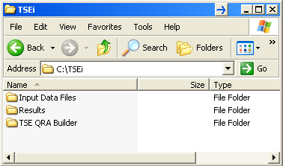

**Figure 2: TSEi folder**

TSE QRA Builder

A user interface has been developed using a form within Excel to change model settings and parameters, and selection of risk management and processing options. This interface has been applied to two example risk assessments: BSE in cattle and scrapie in sheep:

C:\TSEi\TSE QRA Builder\BSE QRA Builder.xltm

C:\TSEi\TSE QRA Builder\Scrapie QRA Builder.xltm

Each template is made up of several core data sheets: surveillance, abattoir, SRM, processing and infectivity. Given these sheets are populated with disease and species specific data to the same age intervals, only slight modifications are required to the BSE or Scrapie QRA Builders to implement the links to simulate new tissue types.

## First time use: load @Risk Reference libraries then save to Microsoft template folder

When opening the QRA templates for the first time the Reference library for your exact version of @Risk needs to be loaded and the resulting two copies saved to Microsoft template folder to preserve the original copies. The Microsoft template folder allows users to open a template file but does not permit changes to be saved to that template thus preserving integrity.

Each QRA template needs to be opened and @Risk also needs to be started if it has not loaded automatically, and all macro’s need to be enabled. To load up the correct Library, ensure that @Risk is loaded, then select Developer>Visual Basic>Tools>References. From the list check the box for Palisade @Risk [version] for Excel Object Library (for your version of @Risk herd) and ensure any files listed as “Missing Palisade @Risk for Excel Object Library” are unchecked. Then press save to make those changes permanent for your version. If you update your version of @Risk this procedure also needs to be followed.

In order to preserve the original template copies, it is recommended to save these two templates to your Microsoft template folder. To locate your Microsoft template folder, open Excel, and select File>Save As, in the *Save As* Type box select “Excel Template (*.xltx)”. This will open the location of your Microsoft template folder, and pressing the down scroller in the top *Save in* box will provide the folder path to this folder from your Desktop. This path will need to be entered when saving the two QRA Builder template files.

Once the QRA Builder templates are located in the Microsoft template folder, to open one of the templates open Excel, select File>New>My templates then select either QRA Builder.

If your computer privileges does not permit saving to this folder, either contact your administrator or save a copy of the original QRA Builders with an amended name in the folder.

## 2.2 Summary of QRA Builder template

On opening the QRA Builder template there are 9 or 10 worksheets. In brief, the first worksheet (red tab) is the “User” worksheet where the button when pressed initiates the user interface. The user interface guides the user through the various options for simulation types, different Member States, parameter changes, and risk management options. The user interface modifies and creates the new bespoke risk assessment which is then saved as a separate file in the “Results” folder, ready for simulating using @Risk. Options are available for checking the input data are available and changing the simulation settings for @Risk.

The remaining worksheets form the building blocks of the risk assessment. These sheets will vary depending on the TSE agent concerned and potentially any scenarios that are being considered. The “Model” worksheet combines all the data from the blue tabbed worksheets to estimate the infectivity at the animal level and country level. The blue worksheets contain the data and are grouped into surveillance data (“Surv”), abattoir data (“Abattoir”), SRM (“SRM”), processing (“Processing”) and infectivity titre (“Infectivity”).

The green worksheet presents results from the final simulation. The grey tab provides a key to the numbers and letters used in the risk assessment nomenclature and index listings for the user interface form. The Scrapie QRA Builder has an additional grey tab named “Resampler” which provides an alternative mechanism to estimate annual results when relatively large numbers of animals may be infected.

By pressing F9 the worksheets will randomly select from any distributions. If this is not occurring check the simulation settings button, and on the General tab select Random Values (Monte Carlo).

## User interface – getting started

Once the TSE QRA Builder files have been moved to your templates, they can be opened by opening Excel, then selecting File>New>My templates. Once opened, @Risk should automatically load. If @Risk does not open, then the program will need to be opened manually at this point.

Once opened, pressing the button on the “User” worksheet named “Model Setup” initiates the user friendly interface in a tabbed layout. The tabs provided are labelled “Simulation”, “SRM”, “Processing”, “Update model settings” and “Save”.

### User interface: Simulation Tab

The first tab on the user form requires the user to select the simulation run. For BSE in cattle the availability of another EFSA model called Cattle TSE Monitoring Model (C-TSEMM) (Adkin et al., 2012) has enabled the development of a number of different simulation scenarios as shown in Figure 3, whilst for the Scrapie demonstration model only one run type is available as shown in Figure 4.

For BSE in cattle, the following simulation types are available:

* Pattern of infectivity. This simulation investigates the trend of infectivity over time at the animal level for fixed ages at slaughter (currently set at 6,12, 18, 24, 36, 48, 60 and 120).
* Country specific data is used to produce results at the animal level and annual level for that area. Age at slaughter is drawn from the population of interest for the baseline year of 2012 (for example, EU27) (data from C-TSEMM)
* Annual estimate of infectivity for previous years with selection of 2007-2011 available drawn from the population of interest e.g. EU27 (data from C-TSEMM)
* Future re-emergence case study where the total estimated number of infected and missed animals until year of detection has been estimated for different member states and the distribution of infected animals in the year of detection (data from C-TSEMM)

At the bottom of the tab, the country selection needs to be made for options 2, 3 and 4.

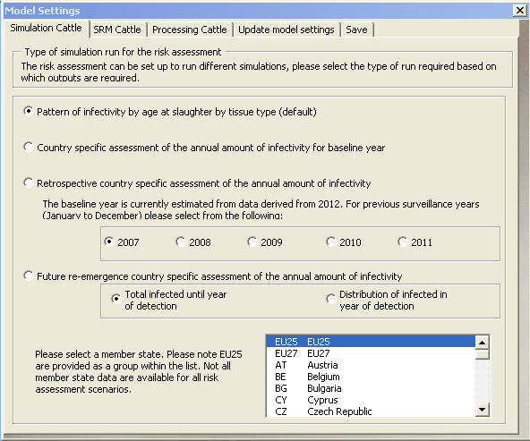

**Figure 3: User interface: Simulation Cattle Tab**

For scrapie in sheep, the country specific simulation of the annual amount of infectivity is available based on data from 2009 (EFSA, 2010).

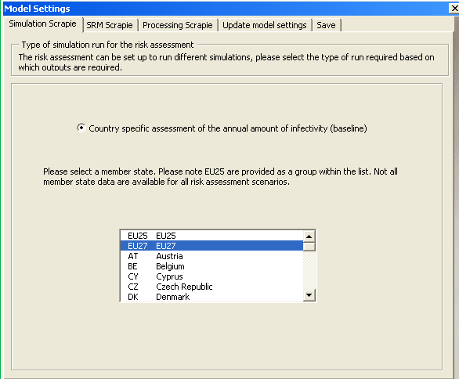

**Figure 4: User interface: Simulation Scrapie Tab**

### User interface: SRM Tab

Risk management controls are provided with list boxes for selecting the age at slaughter at which the named tissue types are deemed to be SRM or not for future scenarios as shown in Figures 5 and 6. Each tissue can be classed as SRM, Not SRM, or a window of SRM classification by age at slaughter is also available. For example, tissues from animals slaughtered between 0 and 48 months could be deemed SRM, whilst tissues from animals slaughtered greater than 48 months can be diverted to the food chain.

For the risk assessment, in the absence of processing, the estimated infectivity of tissues is the same whether they are diverted to SRM or food chain. To produce an economical model if a tissue, or sub group of a tissue defined by the age at slaughter, has been marked as SRM; those materials will be excluded from the model. This permits the user to segregate the population by tissue type or age at slaughter.

For example, if the user wishes to estimate the total infectivity of all tissues types, then the default setting (setting all tissues to “Not SRM at any age”) will accomplish this goal, whether for food chain use or SRM. If the user wishes to only select those tissues that are subsequently processed (duodenum, jejunum, caecum, colon and mesenteries), this can be accomplished by marking ileum as SRM and thus removing it from the analysis.

It should be noted for BSE in cattle the age at slaughter steps are 6 monthly for the first two years then 12 monthly. For scrapie there are only three intervals (<3 months, 3-12 months and >12 months). Therefore, for sheep there is only limited discrimination by age at slaughter, for example >24 months will not reflect any change in the model outputs for scrapie.

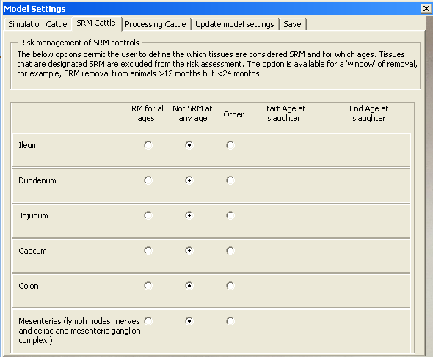

**Figure 5: User interface: SRM Cattle Tab**

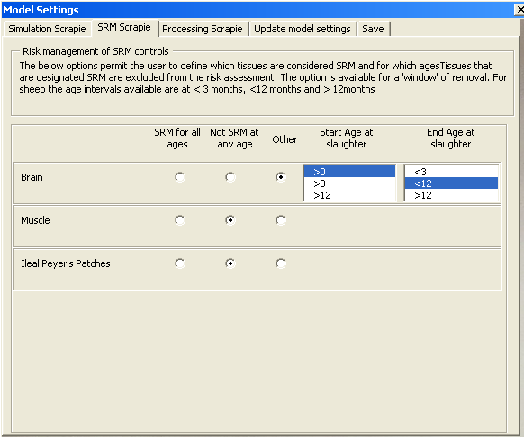

**Figure 6: User interface: SRM Scrapie Tab**

### User interface: Processing Tab

The function of this tab is to enable the user to select tissue types that may undergo further processing. The form permits the user to enter a minimum value and maximum as shown for BSE in cattle in Figure 7. The default settings match those as estimated by the EFSA Working Group, 2013, for bovine intestines and mesenteries. Figure 8 shows the equivalent tab for Scrapie tissues.

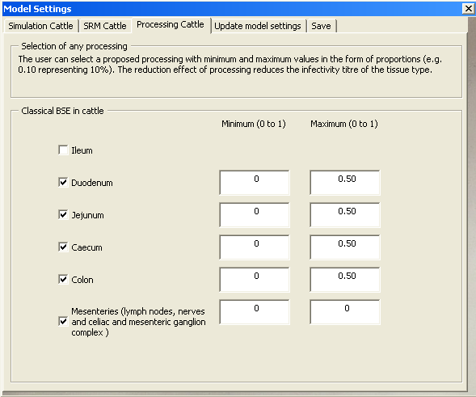

**Figure 7: User interface: Processing Cattle tab**

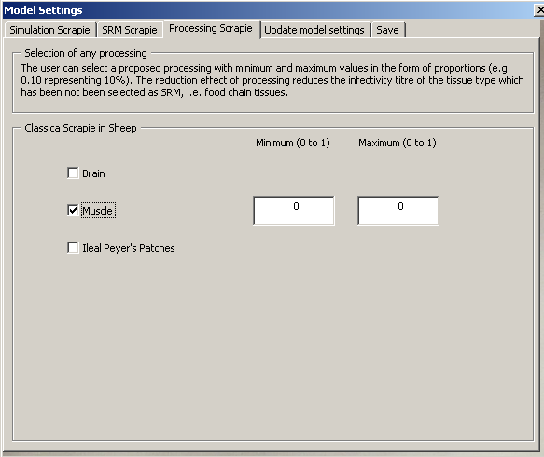

**Figure 8: User interface: Processing Scrapie tab**

### User interface: Update Model Settings Tab

This is an important element of the user interface where users need to sequentially press each button in turn to update the risk assessment according to the selections made on the preceding tabs as shown in Figure 9.

Firstly the user needs to select simulating for uncertainty and variability combined, or running the model including only variable ranges for parameters. Certain models combining uncertainty and variability have been shown to output erratic results where the uncertainty distribution has a major impact on selected model results (Nauta, 2000). During model development it is important to establish if any of the uncertain parameters significantly impact the final model results as it may be better to present results under ‘scenarios’ rather than one result covering a range of uncertain values for example. By the user selecting a ‘variability only’ simulation, results can be compared to those obtained by simulating both uncertainty and variability combined, to identify the impact of inclusion of uncertainty in the model.

Next the model settings need to be updated with each button pressed sequentially with any information supplied in the message boxes followed.

* Input Data Check: When the first button is pressed, the selections made by the user are reviewed and a search made to ensure that all the input files needed for that simulation type/member state/year combination are present in the required locations. If data are absent the user needs to check the relevant input data files: C:\TSEi\Input Data Files
* Update Model Settings: Pressing the second button modifies the risk assessment template according to the choices made by the user. Different parameters and distributions are modified, relevant input data are pasted into the template, different result templates are added and whether the run is including/excluding uncertainty is determined.
* The final button updates the simulations settings as described further in the following sections.
  + - 1. Update Simulation Settings: BSE QRA Builder

The last button on the tab updates the simulation settings to match those requested by the user. The model has been developed with @Risk version 6.1. If previous versions of @Risk are being used, it has been identified that this element may not always work if the Reference Library described in section 2.1 has not been loaded successfully. If previous versions of @Risk are being used the last button can be omitted and the simulation settings manually entered as follows:

For pattern of infectivity by age at slaughter risk assessments:

Number of simulations = 8

Number of iterations = 150000

Macros before simulation = uncheck

Marcos before recalculation = uncheck

Collect distribution samples = None

For all other risk assessment types:

Number of simulations = 1

Number of iterations = 300000

Macros before simulation = check “StartSim” (see Figure 14)

Marcos before recalculation = check “BeforeIt” (see Figure 14)

Collect distribution samples = None (unless you wish to carry out sensitivity analysis refer to section 4.1)

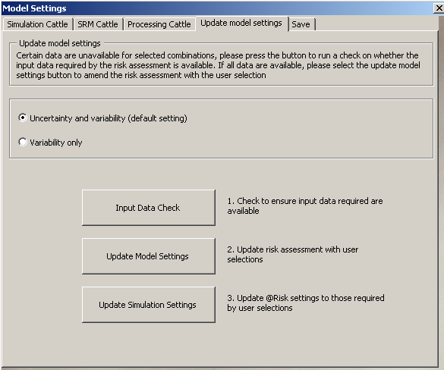

**Figure 9: User interface: Update Model Settings Tab**

* + - 1. Update Simulation Settings: Scrapie QRA Builder

For scrapie, there are a relatively large number of infected animals possible per year. Therefore, the method used for estimating the cumulative infectivity from all infected animals over a year including individual animal variability struggles to achieve convergence unless a large number of iterations are used. Therefore, an alternative method has been implemented in the scrapie QRA builder. In brief, an initial simulation (baseline run) estimates the variable distribution of the infectivity for an infected animal by tissue type by genotype. A second simulation is then performed to estimate the annual cumulative infectivity. For each iteration of this simulation the distribution of the infectivity for one infected animal is repeatedly sampled until it has been sampled the number of times equal to the number of infected carcases in one year. These individual results are summed to estimate the total cumulative infectivity per year.

Pressing the Update Simulation Settings button in the Scrapie QRA builder alerts the user to the initial baseline run about to be performed. The @Risk simulations for the baseline run are as follows:

Number of simulations = 1

Number of iterations = 100000

Macros before simulation = uncheck

Marcos before recalculation = uncheck

Collect distribution samples = None

Once the run has completed the model directs the user to save the model then run the final (annual) simulation. As described, the final simulation uses a VB resampler, so that for each iteration of the model, the cumulative number of carcases is then individually selected and summed. Therefore, for 50,000 infected carcases in one year, for each tissue type, for that iteration, 50,000 separate selections are made and summed from the distribution of infectivity per carcase estimated by the previous baseline run. This resampling takes a relatively long period per iteration but enables a low number of iterations as convergence is achieved with a relatively small sample size. Current convergence has been achieved with as little as 100 iterations.

### User interface: Save Tab

The final tab in the user interface takes the bespoke risk assessment that has been created by the user and saves the file name specified by the user in the location folder: C:\TSEi\Results. As the simulation settings have been set up within the Update Model Settings tab, all that is left is to press the start simulation @Risk button for the simulation to run. Results can be interrogated using @Risk with results saved for that specific risk assessment, with specific graphs produced and an automated sensitivity analysis can be run if distribution samples have been collected.

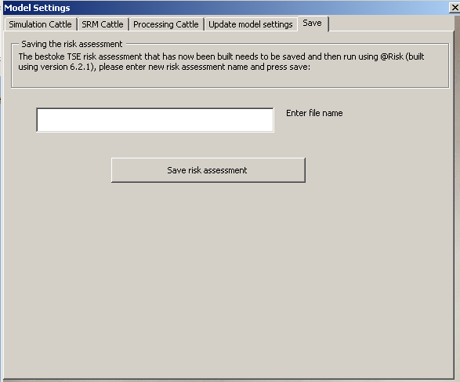

**Figure 10: User interface: Save Tab**

The following sections now review the individual worksheets in detail within the template risk assessment.

## Model worksheet “Model”

This is the key worksheet in the model and combines all the data provided by the data worksheets. There are macros used in this worksheet, therefore no cells should be added or removed from the worksheet. Outputs are segregated on a per animals basis and per year basis. Where outputs have not been selected, cells will state “NA#”.

Prior to initiating a run, it may be useful to press F9 and check that each of the outputs that are being simulated are those required. If a required output is showing “NA#”, it is likely that that tissue has been denoted as SRM in the user interface and therefore will be excluded from the analysis. For any corrections, re-enter the user interface and reselect the appropriate tissues.

## Surveillance worksheet “Surv”

The aim of the surveillance worksheet is to estimate the number of infected animals entering the healthy and emergence slaughter exit streams per year and the characteristics of those animals by-passing controls. The Worksheet(Surv) is divided into Tables of data below a box labelled “Surveillance characteristics for a random infected animal”. The Tables of data provide the distributions for each surveillance characteristic, whilst the top box represents the characteristics for a randomly selected infected individual from that distribution. The Worksheet(Surv) requires data on the:

* Number of infected animals slaughtered
* Any animal population specific characteristics that affect the probability of being infected and slaughtered
* Age at slaughter of infected animals
* Any age related characteristics required to estimate infectivity titre

When considering the application of the template to various TSE agents, tissue types and/or livestock species; the age at slaughter of infected animals needs to be provided. If these data are not available, the age at slaughter of uninfected animals may need to be used as a proxy. Any other age related characteristics that have been identified as important to estimating the titre of infectivity need to be estimated on this worksheet, with the results for a randomly selected animal provided in the top box. For example, when considering the infectivity titres of BSE in cattle in central nervous system tissues, the months prior to clinical onset is likely to be a key determinant of the titre of infectivity. Therefore, a distribution of that characteristic by age at slaughter would be needed as an additional data table, with the relevant value selected for that randomly infected animal listed in the top box.

For the BSE QRA builder for bovine intestines and mesenteries for cattle, an estimate is required for the age at slaughter, age at infection and months post infection at slaughter. The age intervals for cattle start with <6 months, then in 6 monthly intervals up to 36 months, then in 12 monthly intervals to the final band of >204 months producing 21 intervals in total. The number of infected cattle by age at slaughter per year is based on results from C-TSEMM and from an EFSA questionnaire (Adkin et al, 2012; EFSA, 2013). In the absence of further information data are not stratified by BSE strain type. For BSE, there are a number of different simulation types that can be selected by the user using the interface and automatically updated. However, due to the huge variety of outputs that can be produced by C-TSEMM, detailed instructions are available in the Appendix of this report to enable the manual update up the risk assessment for highly specific inputs.

For the scrapie QRA builder there is no analogous model to the C-TSEMM for BSE in cattle and only a demonstration risk assessment has been provided. The characteristics that have been identified as important to the risk assessment are the genotype of the animal and age at slaughter which are included in the worksheet. In terms of age at slaughter intervals, only <3 months, 3-12 months and >12 months age at slaughter are currently available. The number of scrapie infected sheep is estimated by the multiplication of the prevalence of cases in the slaughter stream reported to EFSA for the year 2009 (EFSA, 2010) by the number of animals slaughtered, and a factor to scale from cases to infected animals. The scrapie QRA Builder is currently provided as a demonstration. It is assumed that the age at slaughter is not affected by the presence of infection, that is, the age at slaughter of an infected animal = the age at slaughter of an uninfected individual. Data from a recent EFSA report has been used to populate the worksheet (EFSA, 2010).

For a more robust risk assessment, the parameterisation of the number of scrapie infected sheep using data on the number of sheep cases, sample size, diagnostic sensitivity, and survival to testing age should be completed. A significant difference between BSE and scrapie is the known genetic resistance of certain sheep breeds to scrapie. Therefore, for the scrapie QRA the risk assessment is stratified by genotype. Currently results for the homozygous ARQ/ARQ and VRQ/VRQ are provided.

## Abattoir worksheet “Abattoir”

The aim of this worksheet is to estimate the weight (grams) of each infectious tissue type by age at slaughter. At the top of this worksheet is a box labelled “Abattoir weights for a random animal”. This box displays the weights of tissues for a randomly selected individual drawn from the formula tables listed below. The formula tables are in turn populated by the “Data Tables”; the raw data supplied with references and key assumptions.

The identification of which tissues need to be included within the Worksheet depends on the TSE agent in combination with the livestock species and may be specific to a particular task for the risk assessment. The weights of those infectious tissues identified may be simply derived from the absolute weight of the organ, or may be derived from the concentration of specific infectious structures. Therefore, the calculation of weight is therefore not generic across tissues types and will depend on the relative pathogenesis of that TSE agent and on the type of quantitative data available.

Each tissue type can be identified by a number which subsequently is used by all inputs and results relating to that tissue to discriminate between the tissues types in the risk assessment. For example, for bovine intestines and mesenteries, tissue types 1 to 8 have been identified for inclusion denoting ileum, duodenum, jejunum, caecum, colon, mesenteric lymph nodes, mesenteric nerves and celiac and mesenteric ganglion complex. For the scrapie demonstration tissues types 1 to 6 have been identified representing the two genotypes (ARQ/ARQ, and VRQ/VRQ) for brain, muscle and ileal Peyer’s Patches. Data from a recent EFSA report has been used to populate the scrapie worksheet (EFSA, 2010).

When considering the application of the template to other TSE agents, tissue types and/or livestock species; the weight of each additionally identified tissue type needs to be quantitatively assessed and stratified by the age at slaughter intervals available from Worksheet(Surv). The age intervals for cattle start with <6 months, then in 6 monthly intervals up to 36 months, then in 12 monthly intervals to the final band of >204 months producing 21 intervals in total. For scrapie there are three age intervals (<3 months, 3-12 months and >12 months). Quantitative estimates of the tissue weight for animals slaughtered at each of these ages is needed, or assumptions applied to enable an estimate to be used across certain age groups. Each new tissue will be assigned a unique number. For example, the next BSE in cattle tissue type weight will be denoted $Weight_9$.

For the purpose of the risk assessment in bovine intestine and mesentery, some additional outputs were requested by the EFSA Working Group. These included the infectivity per length and total length of selected tissue types such as ileum, jejunum, duodenum, caecum and jejunum. Therefore, the length (meter) of each of these tissues was estimated and added to the Abattoir worksheet to enable calculation as outputs. In addition, the EFSA Working Group also wanted some outputs of combined tissue types (total ileocaecal plate and jejunual ileocaecal plate) which were also added to the Abattoir worksheet.

## SRM worksheet “SRM”

This worksheet is directly informed by the user interface but can also be manually entered. Each tissue can be classed as “[SRM] for all ages” and thus removed from the analysis, “Not [SRM] at any age”, or a window of SRM classification by age at slaughter is also available. For example, tissues from animals slaughtered between 0 and 48 months can be deemed SRM, whilst tissues from animals slaughtered greater than 48 months can be deemed to enter the food chain.

For each new tissue type added to the worksheet an additional line will be added to describe their SRM status.

## Processing worksheet “Processing”

The aim of this worksheet is to estimate the impact of any processing on the infectivity of tissue types that may enter the food chain. At the top of this worksheet is a box labelled “Processing reduction for a random animal”. This box displays the proportional reduction in infectivity for a processed individual populated by the “Data Tables” where the raw data is supplied with references and key assumptions. The parameters on this worksheet are directly informed by the user interface but can also be manually entered.

For each new tissue type added to the worksheet any processing needs to be considered which may impact on infectivity.

## Infectivity worksheet “Infectivity”

The aim of this worksheet is to estimate the infectivity titre per weight (ID50 per gram) of the infectious tissue type by identified stratification (for example, months post infection or genotype). At the top of this worksheet is a box labelled “Infectivity titre for a random infected animal”. This box displays the infectivity titre for each tissue type from a randomly selected infected animal drawn from the formula tables listed below. The formula tables are in turn populated by the “Data Tables” where the raw data is supplied with references and key assumptions.

When considering the application of the template to other TSE agents, tissue types and/or livestock species; the infectivity titre of each additionally identified tissue type needs to be quantitatively assessed and stratified according to the most appropriate measure of disease progression. For example, for bovine intestines and mesenteries, the most appropriate measure is the months post infection. However, for bovine central nervous system tissues, the months prior to clinical onset may be more relevant. For scrapie infectivity by age at slaughter by genotype has been estimated in a recent EFSA report (EFSA, 2010).

For different TSE agents several different models exist for measuring infectivity titre. For each risk assessment the overall unit of infectivity needs to be agreed with conversion factors available to unify different animals into the same measurement. For example, for the BSE QRA builder the units of log10 RIII i.c. i.p. ID50/g and log10 TgBov i.c. i.p. ID50/g have been used with a conversion factor estimated between the two. However, a conversion value may not be available for all animal TSE models.

The Worksheet(Infectivity) also estimates the final units of the risk assessment. For the BSE QRA builder this is Bovine Oral ID50/g derived from experimental data. For the scrapie QRA builder, the output unit in the absence of any conversion into oral units is C57B16 i.c. ID50/g.

## Results worksheet “Results”

Estimates for the infectivity at the animal level and country level (if available) are presented in the form of mean, 2.5th and 97.5th percentiles. Additional outputs for the BSE QRA Builder have been requested including per animal ID50/m and annual total length of selected tissue types.

The result worksheet uses a function of @Risk to load up specified results of the last simulation made or of a saved simulation results file. Therefore, if a new simulation is undertaken after the initial run, the results on this worksheet are automatically updated. It is useful if the results on this sheet are laid out in the exact order required by any reports.

If the model is opened and @Risk is running, but there are no results visible for any output (#NA or VALUE), the software has not associated the results file with the model file. To open a results file, press the Tools button, select utilities and select Open simulation file as shown in Figure 11. Browse for the Results file as saved by the user and press OK. Large results files take a few minutes to load and may need F9 pressed after loading to refresh values.

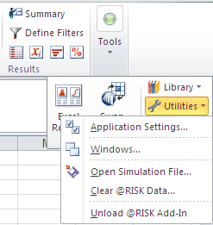

**Figure 11: Opening simulation file using @Risk**

# Running the model

The model parameters can be changed by placing a new value in any of the relevant cells in the surveillance, abattoir, processing or infectivity data worksheets and save a new copy to make the change. The model uses @Risk to implement the stochastic elements and present the results. The simulation settings have been set up for the model using the user interface. Such simulation settings can be changed by the user using the @Risk task bar. To view the simulation settings, press the simulation settings button. Figures 12, 13 and 14 display key aspects of the simulation settings.



## Ensuring convergence with new bespoke models

For the baseline runs created using the user interface the convergence of the model has been assessed based on using the EU27 as the population of interest. This has been completed using the convergence function with @Risk and detailing the level of convergence required as shown in Figure 12 to 4% of the mean statistic. One of the key determinates for the number of iterations required for the TSE QRA builder to converge is the estimated number of infected animals in Worksheet(Surv) and the degree of positive skew on the probability distribution of the titre of infectivity. Therefore, manual changes in both these parameters may significantly alter the number of iterations required.

Therefore, if making manual changes to the risk assessment, outside those enabled by the user interface, the convergence of the model needs to be assessed. The convergence function displays in Figure 12 needs to be checked prior to starting the simulation. Once the simulation has completed the results can then be interrogated to establish whether the level of convergence requested has been achieved. If convergence has not been achieved the number of iterations of the simulation needs to be increased from the General tab shown in Figure 13.

Convergence testing can be enabled to view when the model is converging, however, turning on this function can increase the simulation time.

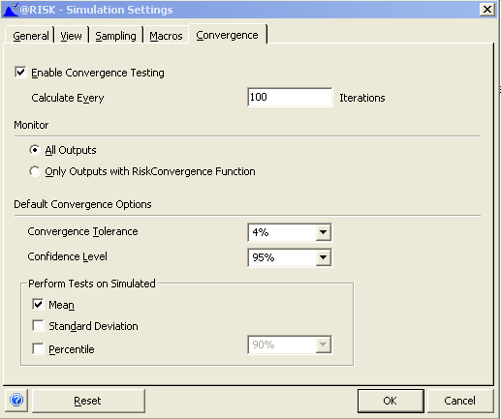

**Figure 12: Simulation settings>Convergence: measuring convergence of simulation**

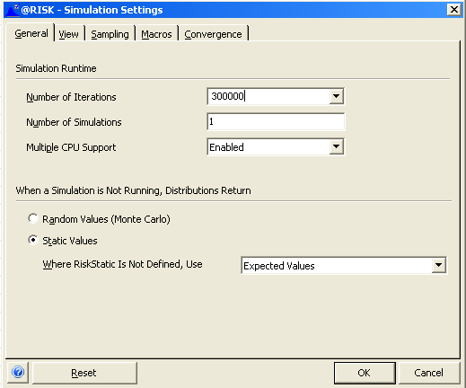

**Figure 13: Simulation settings>General: Changing the number of iterations**

## Macros

Macros between simulations are used in the risk assessment for certain types of runs to perform a resampling within simulations. The macro required for the Scrapie and BSE QRA builders are shown in Figure 14.

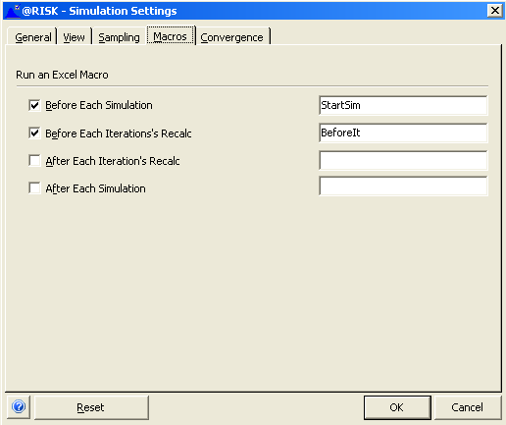

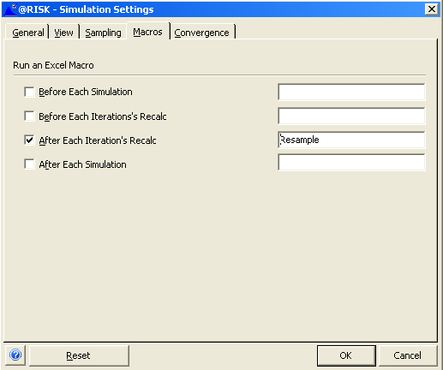

**Figure 14: Macros used during a simulation; LHS Scrapie, RHS BSE**

# Investigating results

Once the simulation is complete, the Results worksheets should automatically update to reflect the new results. @Risk has a number of functions to investigate and visualise outputs and compare different distributions and key statistics. Figure 15 displays the main @Risk buttons involved.





**Figure 15: @Risk result functions and Excel reports**

By highlighting the relevant cell on the Model worksheet and pressing the Browse results button will bring up the distribution of output values for that cell. From viewing the relevant distribution the figure can be modified by pressing the Graph options button on the left hand side, . The distribution type can be changed, legends, scales, and statistics amended. Other distributions can also be overlay by pressing the button . Output distributions can be automatically outputted into Excel reports if specified by the user.

Sensitivity analysis

Sensitivity analysis can be performed to identify those uncertain and variable parameters, which are quantified in the risk assessment, that significantly impact the final results. To investigate areas where the uncertainty or variability may not be quantified in the model, or where different modelling approaches may be used, parameters can be manually varied and the impact on key results compared.

@Risk provides for an automated multivariate stepwise regression analysis to calculate linear regression or sensitivity values for each input parameter in the model represented by a distribution. The regression analysis can be used to measure how the main output (total infectivity per year) varies due to each parameter value selected for that iteration from input distributions. This method is useful for linear models with large numbers of input parameters combined with SMART analysis, as all variables that provide an insignificant contribution are removed from the analysis. Figure 16 displays the sampling tab from the Simulation settings. In order to carry out a sensitivity analysis All distribution samples need to be collected and SMART analysis enabled as shown. Collecting distribution samples increases the simulation time.

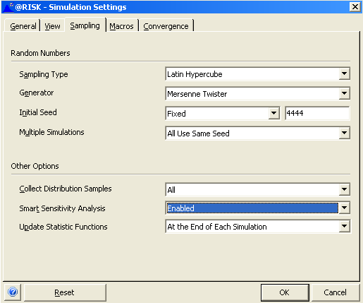

**Figure 16:** Enabling sensitivity analysis before simulation

# Trouble-shooting

The TSE QRA builders are bespoke risk assessments which have been developed to assess both specific queries for EFSA and also to build the templates for queries that may arise over the next few years. Whilst the models have been checked and validated by the project team, computer platforms, computing speed and available resources varying considerably between machines and may affect the functioning of the risk assessment. This section is not exhaustive but displays some of the errors generated when the project team has been using the risk assessment on different machines and therefore is not exhaustive.

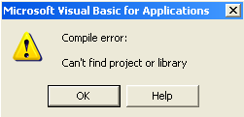

This error occurs when the user tries to update the simulation settings. The correct @Risk version reference library has not been checked by the user, or the user has been switching between versions of @Risk. Please refer to the initial set up instructions in section 2.1.

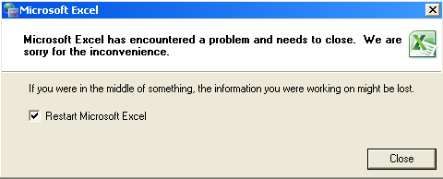

This error has sometimes occurred towards the end of a simulation using @Risk 5.5. with Excel 2010. To remove the message, uncheck the restart box and close the message box.

**Figure 17:** Error messaging

Conclusions

This report provides a user manual for the Scrapie QRA template demonstration and BSE QRA template described in the report “TSE infectivity model (TSEi) in animal tissues: Bovine intestines and mesenteries” **[10]**. The user friendly interface can be used to parameterise the risk assessments for the estimation of TSE infectivity in animal tissues, where data are available, and evaluate the impact of possible risk management measures and processing technologies on residual TSE infectivity.

The user friendly interface permits users to run different scenarios by selection of specific member state surveillance data or groups of member states (EU27), change the impact of processing controls on infectivity, and select different SRM controls at certain ages.

Given specific quantitative input data for additional infectious tissues, both templates can be extended to cover a larger proportion of the tissues infected in animals entering the healthy and emergency slaughter streams for BSE in cattle and scrapie in sheep.

The information required includes an estimate of variability between animals and uncertainty associated with:

* Number of infected animals entering healthy slaughter and emergency slaughter by age at slaughter (scrapie in sheep)
* Proportion of infected sheep by genotype (scrapie in sheep)
* Weight (grams) of additional infectious tissues by age at slaughter
* Effect on estimated infectivity of any processing
* Infectivity titre of additional infectious tissues by period in the incubation period or age at slaughter, and by genotype (for sheep)
* Conversion factors to unify infectious units i.c. i.p. ID50/g, that may have been derived from different rodent models, into bovine oral and ovine oral ID50/g.

Additional information on atypical BSE and scrapie would be required to separately model these diseases.

References

Adkin, A., Simons, R., and Arnold, M. Model for evaluation of different options for the monitoring of Transmissible Spongiform Encephalopathies in cattle in the European Union (C-TSEMM). Supporting Publications 2012: EN-349. [55 pp.]. Available online: www.efsa.europa.eu/publications.

EFSA (2010). EFSA journal 2010; 8(12): 1875

EFSA (2013) Questionnaire for the number of young animals slaughtered by exit stream sent to all EU member states.

Nauta, M. J. (2000) Separation of uncertainty and variability in quantitative microbial risk assessment models. *International Journal of Food Microbiology*. 57: 9-18

Appendix: BSE QRA Builder – manual incorporation of surveillance data into Surveillance worksheet

For BSE in cattle the month post infection is an important characteristic and therefore is estimated in this worksheet from the age at exposure. C-TSEMM provides a large amount of surveillance data into Worksheet(Surv) for the simulation types available (baseline, historic and re-emergence runs). Various distributions are used to estimate the age at slaughter depending on the simulation type selected. These data are provided in Table 5 (Cells C104:H121).These cells provide the input surveillance data for the mean numbers of animals by age at slaughter for each of the different simulations and upper and lower confidence intervals where available (NA where not available).

The BSE QRA Builder is automatically updated through the user interface. However, there may be specific cases where the user may wish to manually enter data to estimate certain case studies. For example, to simulate specific country groupings not provided in the interface, or various user defined parameters using the re-emergence function in C-TSEMM. The following sections details the surveillance data required by each of the simulation types available for BSE in cattle within the Worksheet(Surv), how that data can be generated, and where it can be manually amended by the user for specific case studies.

Worksheet Surv: pattern of infectivity by age at slaughter

For investigating the trend of infectivity by age at slaughter there is no requirement for surveillance data as the model runs sequentially 6, 12, 18, 24, 36, 48, 60, and 120 months. This is completed automatically with the insertion of risk sim tables into cell I6 using the interface. Given an update of the BSE QRA Builder to include central nervous system tissues, it is likely that a longer age at slaughter would provide useful results due to increasing infectivity in those tissues as the animal progresses through the incubation period. Therefore, additional simulations will be added to this scenario extending the age at slaughter to 204 months in 12 monthly intervals.

Worksheet Surv: baseline simulation (2012)

Surveillance data used: C:\TSEi\Input Data Files\BSE\Young Slaughter

C:\TSEi\Input Data Files\BSE\Infected Missed

Pasted into Worksheet(Surv): “Young Slaughter” Table 3 (C64:E67).

“Infected Missed” Table 5 (C104:H121).

Surveillance data generated by:

* The “Young Slaughter” data was generated via questionnaire through EFSA.
* The “Infected Missed” data was generated from C-TSEMM. Section 2.5 of the C-TSEMM user manual (Sensitivity tab) details how these results were generated. Using the second check box stratifies the number of animals infected and missed by surveillance for healthy slaughter and emergency slaughter by age at slaughter for baseline year only. The user needs to ensure that the baseline testing controls (Baseline tab) are those required (for example, with or without testing of the healthy slaughter stream). Outputs from C-TSEMM can be transferred over by renaming the dated C-TSEMM output file (for example 28.06.13) as “Infected Missed” and placed in the folder located: C:\TSEi\Input Data Files\BSE. The file used is named [country]BaselineNumInfAge.csv. The ranges copied over from that file are the healthy slaughter infected (assuming no testing) Range(H2:J19) and the emergency slaughter infected and missed (assuming testing >48 months) Range(Q2:S19).

Where a combination of different member states is needed, C-TSEMM is required to generate the merged country data. For example, if results for EU27+Norway required, those countries need to be selected and data merged using the C-TSEMM interface with results generated as detailed above. The quickest way to update the risk assessment from these data would be to set up the risk assessment for an EU27 baseline simulation using the interface and saving that version. Then from the C-TSEMM results output file EU27-NO “EU27-NOBaselineNumInfAge.csv”, copying over Range(H2:J19) and Range(Q2:S19) to Worksheet(Surv) Range(C104:H121). The “Young slaughter” data would also need updating by adding on the number of young animals slaughtered from Norway to those slaughtered in the EU27 in Worksheet(Surv) Table 3 (C64:E67).

Worksheet Surv: historic simulation (2007 and 2011)

Surveillance data used: C:\TSEi\Input Data Files\BSE\Young Slaughter

C:\TSEi\Input Data Files\BSE\Historical Infected

Pasted into Worksheet(Surv): “Young Slaughter” Table 3 (C64:E67).

“Historical Infected” Table 5 (C104:H121).

Surveillance data generated by:

* The “Young Slaughter” data was generated via questionnaire through EFSA.
* The “Historical Infected” data was generated from C-TSEMM. Section 2.5 of the C-TSEMM user manual (Sensitivity tab) details how these results were generated. Using the second check box stratifies the number of animals infected and missed by surveillance for healthy slaughter and emergency slaughter by age at slaughter and For previous years. Outputs from C-TSEMM can be transferred over by renaming the dated C-TSEMM output file (for example 28.06.13) as “Historical Infected” and placed in the folder located: C:\TSEi\Input Data Files\BSE. The files used are named [country]HistNumInfAgeHSMiss.csv and [country]HistNumInfAgeESMiss.csv. Depending on the year selected depends on which columns from these files are copied and pasted into Table 5 in Worksheet(Surv). For example, selecting the historical year 2007, would entail Range (Q2:S19) from each input file and pasting into to Worksheet(Surv) Range(C104:H121) with healthy slaughter columns first, then the emergency slaughter as labelled in Table 5.

As with the baseline simulation, where a combination of different member states is needed, C-TSEMM is required to generate the merged country data. The C-TSEMM results from [country]HistNumInfAgeHSMiss.csv and [country]HistNumInfAgeESMiss.csv. would then need to be pasted into Table 5 and Table 3 updated to reflect the combined countries data.

Worksheet Surv: re-emergence simulation

Surveillance data used: C:\TSEi\Input Data Files\BSE\Young Slaughter

C:\TSEi\Input Data Files\BSE\Emergence Infected

Pasted into Worksheet(Surv): “Young Slaughter” Table 3 (C64:E67).

“Emergence Infected” Table 5 (C104:H121).

Surveillance data generated by:

* The “Young Slaughter” data was generated via questionnaire through EFSA.
* The “Emergence Infected” data was generated from C-TSEMM. Section 2.6 of the C-TSEMM user manual (Emergence tab) details the different user selections available. For the risk assessment, Method 2 has been used with the following parameterisation:
  + Emergence rate increasing = 0.1
  + Number of cases observed in order for re-emergence to be detected = 1
  + Target age intervals for observed cases = >48, <72
  + The division of infected animals between HS and ES, and CS and ES = Test data 2002-2011
* The user needs to ensure that the scenario testing controls (Scenario tab) are those required (for example, with or without testing of the HS stream). Outputs can be transferred over by renaming the dated C-TSEMM output file (for example 28.06.13) as “Emergence Infected” and placed in the folder located: C:\TSEi\Input Data Files\BSE. The files used are named [country]nMissEmerscen.csv and [country]timeToDet.csv. The [country]timeToDet.csv file provides the mean number of years to detection with upper and lower estimates, which are pasted into column P of Worksheet(Surv). The estimated number of animals infected by age at slaughter are provided in the C-TSEMM file [country]nMissEmerscen.csv shown in Table 1. There are two different datasets depending on whether the user has selected the total number of infected animals accumulated from initiation of the emergence in 2012 until detection year, or the number of infected animals from the year of detection only as shown in Figure 18. If the total accumulation is required from initiation until detection, the mean (columns 2 and 5) and confidence intervals (lower columns 3 and 6, upper columns 4 and 7) are summed with the combined results pasted into to Worksheet(Surv) Range(C104:E121) with blanks in Range(F104:E104). If infectivity from the year of detection is required, then Range(B2:D19) from file [country]nMissEmerscen.csv is pasted into Worksheet(Surv) Table 5.

**Table 1: Surveillance data for the number of animals infected and missed by age at slaughter from C-TSEMM results file [country]nMissEmerscen.csv**



(a) Column 1 is the age at slaughter in months

**(**b) Number of infected animals by age in the year of detection of emergence columns 2, 3, and 4 for mean, lower and upper confidence intervals

(c) Cumulative number of infected animals by age up until the year of detection columns 5, 6 and 7 for mean, lower and upper confidence intervals.

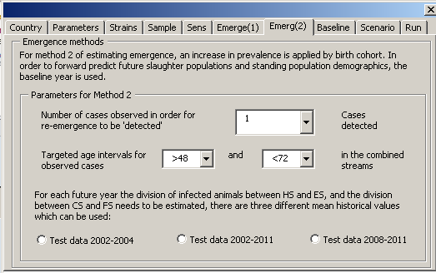

**Figure 18:** Monitoring user form: Emergence (2) tab

There are a large number of different outputs obtainable from C-TSEMM depending on assumptions made on the increasing emergence rate, number of cases to be detected, window for detecting cases and the division of cases based on historical observations. For each of these runs, by copying and pasting the results from C-TSEMM files [country]nMissEmerscen.csv and [country]timeToDet.csv will update the risk assessment according to those changes.

There are additional results available in C-TSEMM for each year in the emergence from the initial year 2012 until detection. Files located in folder:

C:\C-TSEMM\Output Data Files\[date]\EU27\Emer2013\scen provide estimated individual annual results for each exit stream, combined streams (HS+ES and FS+CS) with regards to those estimated to be infected, those detected by the surveillance system set up by the user for the scenario testing controls, and those therefore infected and missed.

For example, the user could select to update and run the risk assessment for the estimated number of infected animals entering healthy and emergency slaughter each year from initiation of emergence until detection. To complete this task, file named [country]nMissedHSES(scen#) can be opened and the relevant year copied and pasted into Worksheet(Surv) Range(C104:C121) with remaining cells in Table 5 kept blank. There are no estimated confidence limits for each individual year in the emergence. Other examples include the user changing the surveillance of the scenario and estimating the impact on the number of infected animals due to decreased surveillance. In this way different surveillance schemes can be compared according to the estimated amount of infectivity arising from healthy slaughter and emergency slaughter animals (currently from bovine intestines and mesenteries).

Glossary [and/or] abbreviations

BO Bovine Oral

BSE Bovine Spongiform Encephalopathy

Cases Test positive animal that are tested.

CI Confidence Interval

CMGC Celiac and mesenteric ganglion complex

ES Emergency slaughtered risk category

HS Healthy slaughtered risk category

i.c. Intracerebral inoculation

i.p. Intraperitoneal inoculation

mpi Months post infection

MS Member State of the European Community

PP Peyer’s patches

QRA Quantitative Risk Assessment

TSE Transmissible Spongiform Encephalopathy

VB Visual Basic

1. Question No EFSA-Q-YYYY-NNNNN.
2. Regulation (EC) No 999/2001 of the European Parliament and of the Council of 22 May 2001 laying down rules for the

   prevention, control and eradication of certain transmissible spongiform encephalopathies. OJ L 147, 31.5.2001, p. 1-40.
3. http://www.efsa.europa.eu/en/efsajournal/pub/2104.htm
4. http://www.efsa.europa.eu/en/efsajournal/pub/1875.htm
5. http://www.efsa.europa.eu/en/efsajournal/pub/700.htm
6. http://www.efsa.europa.eu/en/efsajournal/pub/220.htm
7. Available at: http://ec.europa.eu/food/food/biosafety/tse_bse/docs/roadmap_2_en.pdf
8. Seuberlich T, Gsponer M, Drögemüller C, Polak MP, McCutcheon S, Heim D, et al. Novel prion protein in BSE-affected cattle,

   Switzerland. Emerg Infect Dis. 2012 Jan. http://wwwnc.cdc.gov/eid/pdfs/11-1225-ahead_of_print.pdf
9. REFERENCE TO LOCATION OF MAIN REPORT
10. LINK TO MAIN REFERNCE